For all participants unable to submit the projects in the designated Archives in person, the organizers of the Competition have decided to permit submission of the projects via e-mail. In order to ensure confidentiality protocols the organizers require the participants to follow the procedure described and illustrated below.
The e-mail and file transfer platforms used for description of the procedure are not obligatory, they are used for illustrational purposes.
Competitors are required to create an email address opened only and specifically for the purpose of this competition Call for Entries: International competition for preparation of preliminary urban and architectural development design for arrangement of the Kale Hill in Skopje. Please follow the example illustrated below:
Open a new e-mail account. In the First name section required by the e-mail platform, please insert “kalehill” as a reference to the Competition.
In the Last name section required by the e-mail platform, please insert a code with minimum five (5) characters under which your proposal will be registered. This is obligatory as indicated in T.1. COMPETITION TERMS AND CONDITIONS.
VIII FORMAT FOR SUBMISSION OF THE WORKS
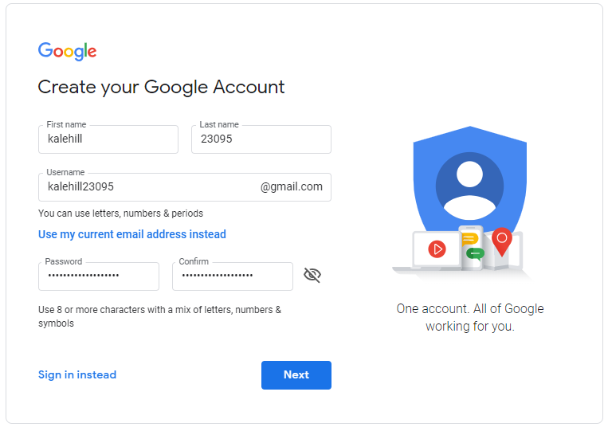
8.1. The competition work is submitted under a code with 5 characters (numbers and/or letters), which should be indicated on each of the appendices (textual and graphic), placed in the upper right corner.

In all upcoming required fields, which vary and depend on the platform, we kindly ask you to pay attention not to insert information which reveals your identity and may therefore compromise the confidentiality requirements of the Competition.
All submissions where there would be an articulation of a first name or a last name which is not provided as indicated by the instructions will be considered invalid and will not be reviewed by the Competition Jury.
Once you have opened a new e-mail address, please send several test e-mails to your personal e-mail to ensure that the messages received contain no trace of data relatable to you.
After having tested and ensured the anonymity of your e-mail address, please refer to a file transfer platform (e.g. WeTransfer) where you will attach your files in original size and share send the link to the following e-mail address: konkurs_kkt2@msu.mk.
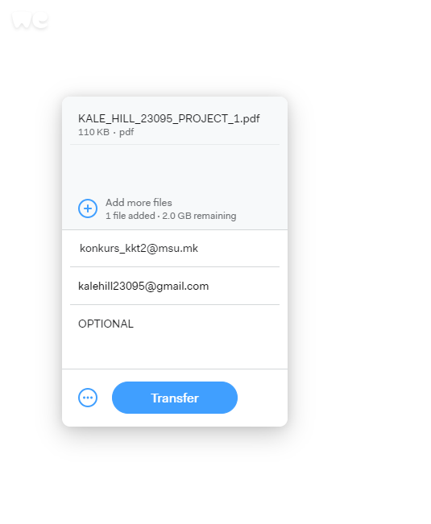

If the platform provides the option, we kindly ask you to request a confirmation that your files have been sent and a confirmation that the files have been downloaded.
If you need to send several links due to the size of your files, please make sure you number the files in chronological order (e.g. KALE_HILL_23095_PROJECT_1, KALE_HILL_23095_PROJECT_2, etc).
As a final step, in a separate e-mail from that of the submitted proposal, all participants are obligated to submit a signed and scanned statement to the same e-mail address: konkurs_kkt2@msu.mk.
VIII FORMAT FOR SUBMISSION OF THE WORKS
8.5. Enclosed with the competition work should be submitted a single nontransparent sealed envelope, with the designation “AUTHOR”, marked with the same code as the appendices. The envelopes should contain: Name and surname (names and surnames) of the author, contact address and phone number. Each author should include their hand signature on A STATEMENT by which they acknowledge that they accept the Terms and Conditions of the Competition.
The Competition Committee does not have access to the designated e-mail address. The identity of the participants will not be disclosed to the Competition Committee prior to the publication of the official results on the official website of the Museum of Contemporary Art – Skopje by 29.05.2019.

